**Dheeraj Prajapati**

**Tutorial – 1**

1. Write a C program to print “Hello World” on the output screen.

#include<stdio.h>

#include<conio.h>

void main()

{

//This program is to demonstrate print function

clrscr();

printf(“Hello World”);

getch();

}

**Output:**

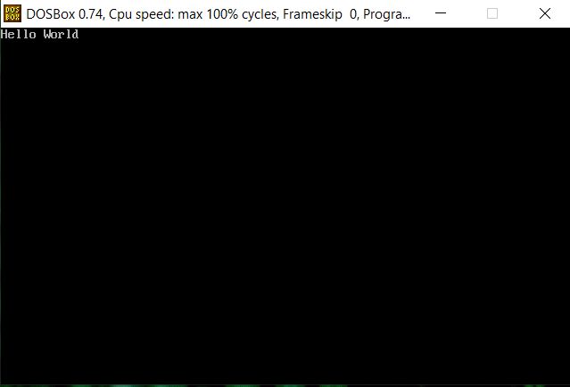

**2.** **2 : Design your profile page as given below.**

**OUTPUT:**

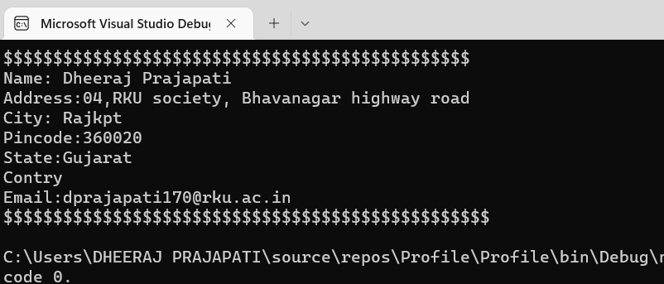

**3.** **Find out whether the given number is odd or even.**

**Code**

using System;

namespace dotnet_sample

{

class Program

{

static void Main(string[] args)

{

int n;

Console.WriteLine("Enter a number to check : ");

n = int.Parse(Console.ReadLine());

if (n % 2 == 0)

{

Console.WriteLine(n + " is an even number");

}

else

{

Console.WriteLine(n + " is an odd number");

}

}

}

}

**Output:**

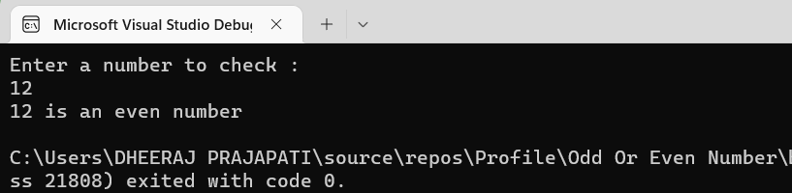

**4.** **Rearrange the given code to correct the program. The resultant program will be to input a number and print whether the given number is odd or even.**

using System;

namespace ConsoleApplication1

{

class program

{

static void Main(String[] args)

{

int x;

Console.WriteLine("Enter Number : ");

//x = Convert.ToInt32(str);

x =int.Parse (Console.ReadLine());

if (x % 2 == 0)

{

Console.WriteLine("Number is Even");

}

else

// Console.Read();

Console.WriteLine("Number is Odd");

}

}

}

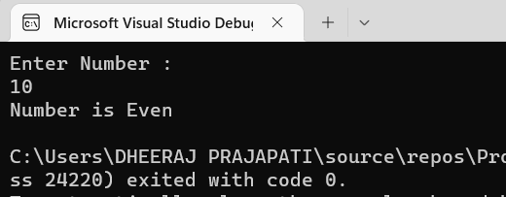

**5 : Write output of the program. Also write comment for each line for the following code.**

using System;

namespace ConsoleApplication1

{

class Program

{

static void Main(string[] args)

{

int n, fact = 1;

Console.WriteLine("Enter Number : ");

string str = Console.ReadLine();

n = Convert.ToInt32(str);

for (int i = 1; i <= n; i++)

{

fact = fact * i;

}

Console.WriteLine("Factorial : {0}", fact);

Console.Read();

}

**}**

**Code:**

using System; //It is the system library

namespace ConsoleApplication1 //It is used to declare a scope that contains a set of related objects

{

class Program //It defines a type of object

{

static void Main(string[] args) //Main Method can be called without an object.

{

int n, fact = 1; //Variable Declare

Console.WriteLine("Enter Number : "); //UserInput

string str = Console.ReadLine();//It is used to read the complete string until the user presses the Enter key or a newline character is found.

n = Convert.ToInt32(str); //Converts the specified string representation of a number to an equivalent 32-bit signed integer

for (int i = 1; i <= n; i++) //It is a loop to iterate the value

{

fact = fact * i;

}

Console.WriteLine("Factorial : {0}", fact); //It is a logic

Console.Read();//It is used to read the input

}

}

}

}

**Output:**

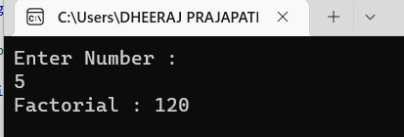

**6 : Write missing statement to get the desired output.**

**CODE:**

using System;

namespace ConsoleApplication1

{

class Program

{

static void Main(string[] args)

{

int a, b, c, result;

Console.Write("Enter Number 1: ");

//Missing statement

string str = Console.ReadLine();

a = Convert.ToInt32(str);

Console.Write("Enter Number 2 : ");

//Missing statement

string str1 = Console.ReadLine();

b = Convert.ToInt32(str1);

Console.Write("Enter Number 3 : ");

string str2 = Console.ReadLine();

//Missing statement

c = Convert.ToInt32(str2);

result = Sum(a, b, c);

//Missing statement

Console.WriteLine(result);

}

static int Sum(int x, int y, int z)

{

int res;

res = x + y + z;

return res;

}

}

}

**OUTPUT:**

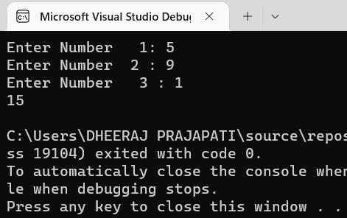

**7.**

     using System;  
namespace While_Loop  
{  
  class Program  
   {  
     static void Main(string[] args)  
      {  
        int num1,res, i;  
   
        Console.WriteLine("Enter a number");  
        num1 = Convert.ToInt32(Console.ReadLine());

        i = 1; //Initialization

        //Check whether condition matches or not  
        while (i <= 10)  
         {  
           res = num1 * i;  
           Console.WriteLine("{0} x {1} = {2}", num1, i, res);

                i++; //Increment by one  
         }  
        Console.ReadLine();             
      }  
   }  
}

**output:**

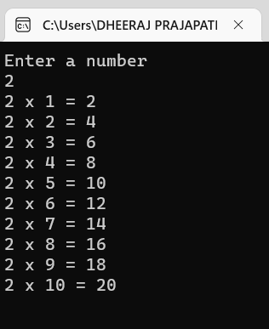

8.Write a program to convert given name in upper characters

Input :john f kennedy

Output: JOHN F KENNEDY

**Code**

using System;

class Program

{

// Main Method

public static void Main()

{

string str1;

Console.WriteLine("Enter a name : ");

str1 = Convert.ToString(Console.ReadLine());

string upperstr1 = str1.ToUpper();

Console.WriteLine(upperstr1);

}

}

**Output:**

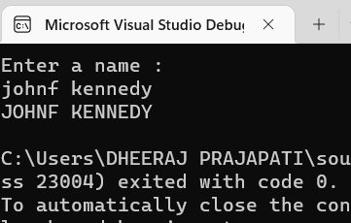

9. Write a Program to convert given name in toggle case.

Input: JoHn F kEnNedy

Output: jOhN f KeNneDY

**CODE:**

using System;

public class exercise15

{

public static void Main()

{

string str1;

char[] arr1;

int l, i;

l = 0;

char ch;

Console.Write("\n\nReplace lowercase characters by uppercase and vice-versa :\n");

Console.Write("--------------------------------------------------------------\n");

Console.Write("Input the string : ");

str1 = Console.ReadLine();

l = str1.Length;

arr1 = str1.ToCharArray(0, l); // Converts string into char array.

Console.Write("\nAfter conversion, the string is : ");

for (i = 0; i < l; i++)

{

ch = arr1[i];

if (Char.IsLower(ch)) // check whether the character is lowercase

Console.Write(Char.ToUpper(ch)); // Converts lowercase character to uppercase.

else

Console.Write(Char.ToLower(ch)); // Converts uppercase character to lowercase.

}

Console.Write("\n\n");

}

}

**OUTPUT:**

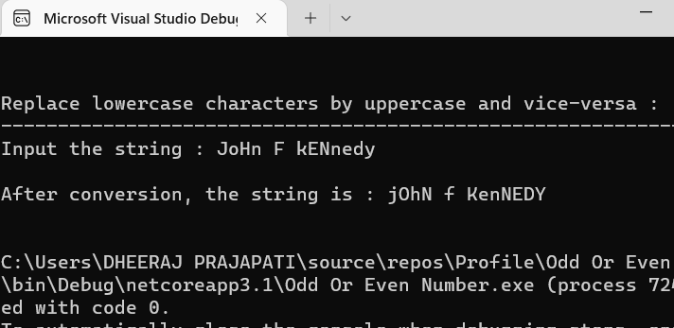

 10.Write a Program which accepts mobile no as a string from the user and converts the last 5 digits into X.  
INPUT : 1234567890  
OUTPUT: 12345XXXXX

**CODE:**

using System;

using System.Linq;

using System.Collections.Generic;

public class Program

{

public static void Main()

{

string source;

Console.WriteLine("Enter a phone number (10 Digit Only)");

source = Convert.ToString(Console.ReadLine());

int chunkSize = 5;

List<string> chunks = (from i in source.ToCharArray().Select((value, index) => new { Value = value, Index = index })

group i.Value by i.Index / chunkSize into g

select g).Select(x => string.Join("",x)).ToList();

Console.WriteLine(chunks.First()+"XXXXX");

}

}

**OUTPUT:**

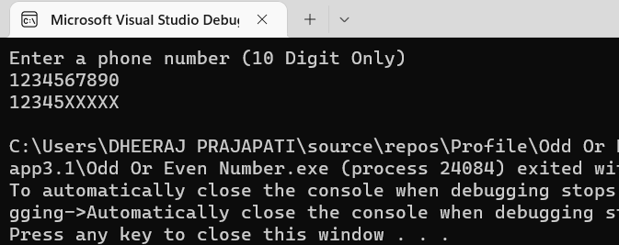

**11.** Write a Program which accepts name and gender from the user. Here, gender may have only 1 character, M or F.

Based on the gender prefix the name Mr. & Ms.

NAME:HillaryClinton  
GENDER :F

**CODE:**

using System;

class dp

{

static void Main(string[] args)

{

string name;

char gender;

Console.WriteLine("Enter the name");

name = Convert.ToString(Console.ReadLine());

Console.WriteLine("Enter the gender(If male enter M & if female enter F");

gender = Convert.ToChar(Console.ReadLine());

if (gender == 'M')

{

Console.WriteLine("Mr. "+name);

}

else

{

Console.WriteLine("Ms. " + name);

}

}

}

**OUTPUT:**

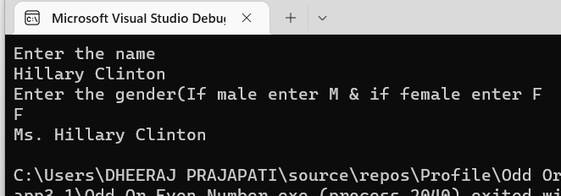

12. Write a Program which accepts name from the user and prints the same  
INPUT:Winston Churchill.  
OUTPUT: Winston Churchill

**CODE:**

using System;

class DP

{

static void Main(string[] args)

{

string name;

Console.WriteLine("Enter a name : ");

name = Convert.ToString(Console.ReadLine());

Console.WriteLine("===============================");

Console.WriteLine(name);

}

}

**OUTPUT:**

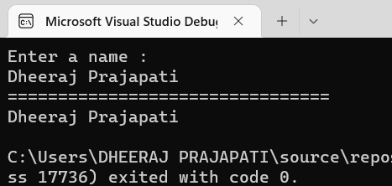

13.Write a Program to prints the following series

0 1 1 2 3 5 8 13 21 34 55

**CODE:**

using System;

class DP

{

static void Main(string[] args)

{

int n = 11, n1 = 0, n2 = 1, n3;

/* Console.WriteLine("Enter a number");

n = Convert.ToInt32(Console.ReadLine());*/

Console.Write(n1 + " " + n2 + " ");

for (int i = 2; i < n; ++i)

{

n3 = n1 + n2;

Console.Write(n3 + " ");

n1 = n2;

n2 = n3;

}

}

}

**OUTPUT:**

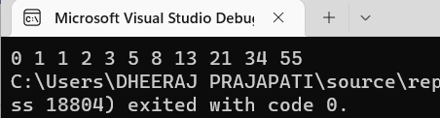

14. Write a Program which accepts no from the user and print the same in words

INPUT : 98732

OUTPUT: Nine Eight Seven Three Two.

**CODE:**

using System;

class DP

{

static void Main(string[] args)

{

int num, rev = 0;

int digit, rem;

Console.WriteLine("Enter the number");

num = Convert.ToInt32(Console.ReadLine());

while (num > 0)

{

rem = num % 10;

rev = rev * 10 + rem;

num = num / 10;

}

while (rev > 0)

{

digit = rev % 10;

switch (digit)

{

case 1:

Console.WriteLine("One ");

break;

case 2:

Console.Write("Two ");

break;

case 3:

Console.Write("Three ");

break;

case 4:

Console.Write("Four ");

break;

case 5:

Console.Write("Five ");

break;

case 6:

Console.Write("Six ");

break;

case 7:

Console.Write("Seven ");

break;

case 8:

Console.Write("Eight ");

break;

case 9:

Console.Write("Nine ");

break;

case 0:

Console.Write("Zero ");

break;

default:

Console.WriteLine("Something went wrong!!(Please enter 1-9 digit");

break;

}

rev = rev / 10;

}

}

}

**OUTPUT:**

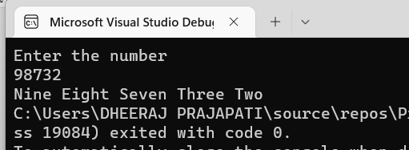

15. Write a Program to check whether the given no is Armstrong no or not.

**CODE:**

using System;

public class Armstrong

{

public static void Main(string[] args)

{

int n, r, sum = 0, temp;

Console.Write("Enter the Number= ");

n = int.Parse(Console.ReadLine());

temp= n;

while (n > 0)

{

r = n % 10;

sum = sum + (r * r * r);

n = n / 10;

}

if (temp == sum)

Console.Write("It is a Armstrong Number.");

else

Console.Write("Not Armstrong Number.");

}

}

**Output:**

